**WBMMF – Next Generation Duplex Multimode Fiber**

**Summary**

Enterprise data center and cloud operators use multimode fiber for most of their deployments because it offers the lowest cost means of transporting high data rates for distances aligned with the needs of these environments. The connections typically run at 10G over a duplex multimode fiber pair—one transmit (Tx) fiber and one receive (Rx) fiber. Upgrading to 40G and 100G using MMF has traditionally required the use of parallel ribbons of fiber. While parallel transmission is simple and effective, continuation of this trend drives higher cost into the cabling system. However, a new generation of multimode fiber called WBMMF (wideband multimode fiber) is on the way, which can enable transmission of 40G or 100G over a single pair of fibers rather than the four or ten pairs used today.

**Why parallel multimode is simple and effective over duplex ?**

Optical fiber’s ability to deliver increased bandwidth over longer distances compared to twisted-pair and wireless media options make it an ideal choice for data center and building planners looking for a path to 10, 40 or 100 Gigabit Ethernet. There are two optical fiber types used in inter-networking applications—multimode and single-mode fiber. The key difference is in the physical core sizes of the fiber. Laser optimized multimode fiber utilizes a 50 micron core, whereas single-mode fiber is characterized by a smaller core size in the range of 8 to 10 micron. Multimode fiber typically serves as the cabling backbone in commercial buildings and data centers, as it connects the aggregation network layer to the core and access layers. Single-mode fiber is ideal for covering long distances, in the order of kilometers, between buildings or within the backbone of hyper scale data center environments. Multimode fiber is the more economical choice for most commercial buildings and smaller data centers. Multimode infrastructure has the advantage of utilizing lower-cost short wavelength optics operating at 850 nm, which drives a lower overall system cost compared to the more expensive single-mode optics, which use longer wavelength optics in the 1310 to 1550 nm range. Multimode fiber can support data rates in the range of 1 to 100 Gigabits per second. Depending on the type of optical transceiver that is used, these data rates can be delivered via duplex or parallel transmission over multimode fiber. Duplex transmission has a single-lane or serial architecture that can support data rates of 10 to 40 Gigabits per second. A duplex architecture is desirable, as it minimizes the number of fibers required to support the desired data rate. One fiber is used to transmit and the other to receive data. Parallel transmission utilizes multiple lanes that can support 40 to 100 Gigabit per second data rates; however, parallel architectures require multiple fibers to transmit and receive data. In the case of 40 Gigabit Ethernet, many short wavelength parallel optical transceivers require 4 lanes using 8 fibers. The early generation 100 Gigabit short wavelength transceivers required 10 lanes or 20 fibers to operate .While parallel transmission provides an economical choice for high-speed data center backbones, careful planning is required due to the increased complexity associated with parallel versus duplex infrastructures.

**A brief history of WBMMF and problems with OM series until OM5**

MMF is a cost-effective solution in these environments, thanks to its high tolerance for fiber misalignment and relatively low connection loss at each connector interface. Multimode fiber cabling systems – combined with LEDs and VCSEL (vertical-cavity surface-emitting laser)-based optical transceivers – are ideal for short-reach optical interconnects.The channel capacity of multimode fiber has multiplied by using parallel transmission over several fiber strands (four or 16, with collections of 25 Gbps lanes carried in each direction). But this method raises cabling system prices. Initially developed to support Fast Ethernet OM1 and OM2 multimode fiber cable can no longer support 10 Gbps and 25 Gbps data transmission speeds. In the ANSI/TIA-568.3-D Standard, OM1 and OM2 multimode fiber types have been “grandfathered” in, and are not recommended for new installations. Until recently, OM3 and OM4 (laser-optimized multimode fiber [LOMMF]) were the mainstream multimode fiber cabling choices to support 10G, 40G and 100G Ethernet, [InfiniBand](http://www.infinibandta.org/" \t "_blank) and [Fibre Channel](http://fibrechannel.org/" \t "_blank) protocols. As bandwidth requirements increase much faster than the VCSEL-based transceiver technology curve, however, it’s becoming more costly for optical fiber cabling systems to support next-generation Ethernet speed migration.

Wideband multimode fiber (WBMMF) is an ANSI/TIA development that can deal with escalating data rates and the infrastructure required to support higher bandwidth. It uses wavelengths to increase each fiber’s capacity by at least a factor of four, which allows at least a fourfold data-rate increase (or a fourfold reduction in the number of fibers required to achieve a given data rate. Instead of using four separate fibers to transmit four optical signals, the signals can be sent down one fiber over four separate operating windows. [ANSI/TIA-492AAAE](http://www.cablinginstall.com/articles/2016/07/tia-standard-wbmmf-wideband-multimode-fiber.html), the new wideband multimode fiber standard, was approved for publication in June 2016 after a 20-month, industry-wide study carried out by a special TIA taskforce within TR-42.11 (Optical Systems Subcommittee) and TR-42.12 (Optical Fibers and Cables Subcommittee). The International Organization for Standardization/International Electrotechnical Commission (ISO/IEC) has recently decided on the nomenclature for wideband multimode fiber cable: OM5. This new fiber cable standard has already been referred to by the IEEE 802.3 working group for next-generation Ethernet standard development. Please note that the TIA-492AAAE document specifies the raw glass fiber performance for the wideband operation, while ISO/IEC OM5 and TIA 568.3-D specify the cabled fiber performance containing the wideband multimode fiber.

[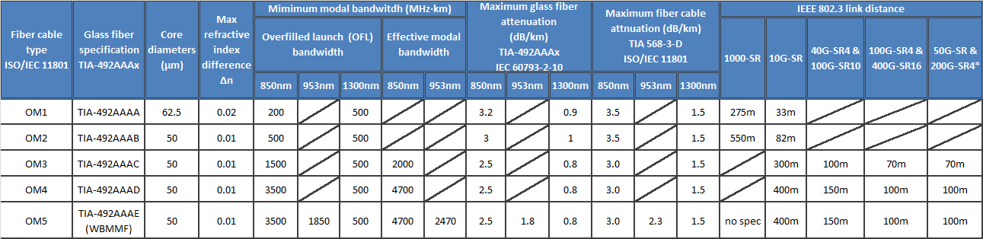](https://www.belden.com/webadmin/blog/images/MMF-Standard-Specifications_QXv2.png)

The table above represents different multimode fiber standard specifications and their supported link distances for IEEE 802.3 Ethernet applications.

**Technology behind WBMMF**

**OM5 :** The OM5 optical and mechanical attributes are compliant with OM4 50/125 μm specifications and include the additional specifications of effective modal bandwidth and attenuation at 953 nm. WB MMF is intended for operation using vertical-cavity surface-emitting laser (VCSEL) transceivers across the 846 to 953 nm wavelength range.

**SWDM :** SWDM is a proprietary wavelength division multiplexing (WDM) technology that uses four wavelengths across the 850 to 940 nm range. SWDM transceivers were designed to use 2-fiber connectivity into the transceiver with OM3/OM4. SWDM VCSEL transceivers are expected to be commercialized throughout 2017. See figure 1.

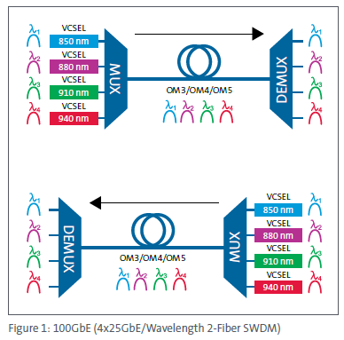

As OM3 and OM4 provide very high laser-optimized modal bandwidth at 850 nm, the predominant wavelength of multimode applications. But to provide equivalent performance over a range of wavelengths needed to support low-cost wavelength division multiplexing (WDM) requires a new fiber specification because the modal bandwidth of OM3 and OM4 can diminish quickly when operated at different wavelengths, making them less than ideal for supporting WDM lane rates above 10 Gb/s per wavelength. Recognizing that the chromatic bandwidth of fiber improves as wavelength increases above 850 nm, and that proprietary applications like Cisco’s 40G-SR-BD (40 Gb/s using bi-directional transmission per fiber) employ 850nm and 900nm VCSELs, leads to a fiber specification starting at 850 nm and moving towards longer wavelengths. Figure 2 below shows WDM concept showing four wavelengths Low-cost WDM requires a nominal separation between wavelengths of about 30 nm. The need to well support at least four wavelengths, as depicted in Figure 2, leads to a necessary wavelength range, including guard bands, of at least 100 nm spanning across 850 nm to 950 nm. Figure 3 - Conceptual bandwidth comparison The motivation for initiating the new standards project is to improve the utility of multimode fiber to better support future applications while also fulfilling the needs of present applications. This motivation was shared by TIA’s TR-42.11 and TR-42.12 subcommittees which approved the start of the new project without dissent.

**Figure 2 :** WDM concept showing four wavelengths 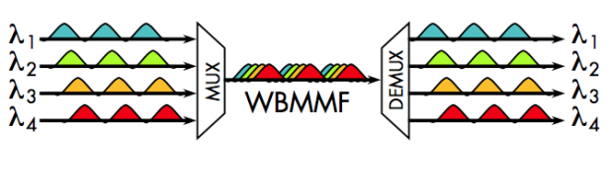

Figure 3 - Conceptual bandwidth comparison 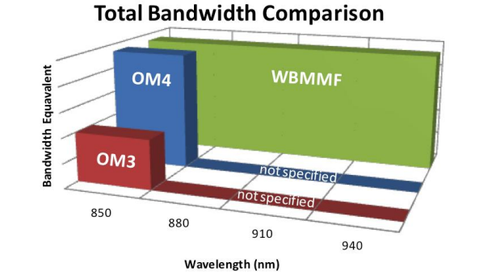

**Goals and benefits**: • Retain legacy application support of OM4 • Increase capacity to > 100 Gb/s per fiber • Reduce fiber count by 4× • Enable Ethernet: 100G-SR, 400G-SR4, 1600G-SR16 • Enable Fibre Channel: 128G-SWDM4 • Increase MMF’s utility • Extend MMF’s value to customers.

**Why Does WBMMF Make Sense?**

In order to increase transmission speeds up to 10G or 25G, transceiver vendors simply increased the speed of their devices. When 40G and 100G standards were developed, transmission schemes that used parallel fibers were introduced. This increase in fiber count provided a simple solution to limitations of the technology available at the time. It was accepted in the industry and allowed multimode links to maintain a low cost advantage. However, the fiber count increase was not without issues. At some point, simply increasing the number of fibers for each new speed became unreasonable, in part because the cable management of parallel fiber solutions, combined with the increasing number of links in a data center, becomes very challenging. Please see the picture below. Usually, 40G is implemented using eight of the twelve fibers in an MPO connector. Four of these eight fibers are used to transmit while the other four are used to receive. Each Tx/Rx pair is operating at 10G. But if we use WDMMF, two fibers are enough. Each Tx/Rx pair can transmit 40G by simultaneously transmitting four different wavelengths. This enables at least a four-fold reduction in the number of fibers for a given data rate, which provides a cost-effective cabling solution for data center.

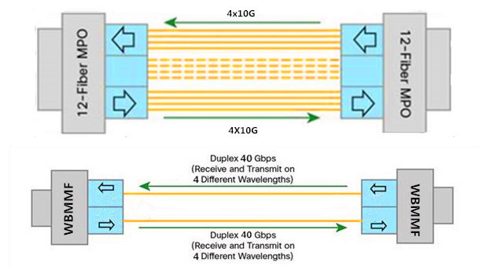

**Conclusion**

WBMMF is born at the right moment to meet the challenges associated with escalating data rates and the ongoing need to build cost-effective infrastructure. Besides, WBMMF will support existing OM4 applications to the same link distance. Optimized to support wavelengths in the 850 nm to 950 nm range to take advantage of SWDM, WBMMF ensures not only more efficient support for future applications to useful distances, but also complete compatibility with legacy applications, making it an ideal universal medium that supports not only the applications of the present, but also those of the future.

**Online Blog References:**

* Belden Inc ,website: https://www.belden.com
* Anixter Inc ,website: https://www.anixter.com
* Fluke networks Inc ,website: http://www.flukenetworks.com
* Graybar Inc ,website: https://www.graybar.com

**Submitted By : BIJON SAHU (1647781) ECE:6323**